IMSE882: Network Flows and Graph Theory
Homework One
TRAC Group Submission
Anderson, Rochelle  Cameron, John  Conrad, Blake  Cooke, Stuart  Hinds, Jason  Krause, Joshua | Quint, Kalen  Scott, Christian  Serota, Doug  Silvers, David  Urabe, Katie  Yetman, Piper
19 February 2019

Problem 1 (Primary Silvers / Alternate Quint)
Prove that a graph is a tree if and only if it is connected and has exactly n-1 edges.

A tree is defined as an undirected graph in which any two vertices are connected by exactly one path.
Proof (Step 1, a tree has n-1 edges): Build a tree, beginning with a set of n vertices v ϵ V, G(V,E), according to the definition of a tree that any two vertices are connected by exactly one path. Add edges to form a connected acyclic graph.
WLOG, add edges to the vertices, starting with v1. To add edge e1 without forming a cycle, place edge from v1 to v2.
Next, add edge e2 to v2 without forming a cycle. This means the edge cannot connect from v2 to v1, so have it connect from v2 to v3.
Again, add edge e3 to v3 without forming a cycle. This means the edge cannot connect from v3 to v2, v1, or any vj with j < 3, so have it connect from v3 to v4.
Continue adding an edge to vi without forming a cycle. This means the edge cannot connect from vi to any vj with j < i, so have it connect from vi to vi+1. Edge en-1 will connect node vn-1 to vn.
No fewer than n-1 edges can be added, because if there are only m edges (m less than n-1) then there are (n-1-m) nodes which are not connected to the graph, since only nodes up to vm+1 are connected.
No more than n-1 edges can be added. If an additional edge en, is added, then it has to connect to some node vj, j < n, which means there will be a cycle from node vj back to vj. Therefore, the graph G(V,E) is a tree if it is connected and has n-1 edges.
Proof (Step 2, a connected graph with n-1 edges is a tree): Assume a graph G(V,E) is connected with exactly n-1 edges.
By contradiction, remove any edge such that there are n-2 edges and G is a tree (any two vertices connected by exactly one path). However, removing an edge (n-2 edges total) means that G can be divided into two components, since breaking an acyclic edge means the graph can be dividing into two sets of connected vertices. By removing more than one edge (n-j edges total, j > 2), G can be broken down into more than two components. Removing any number of edges such that there are fewer than n-1 edges means G has at least two components and therefore is not connected. This is a contradiction since G cannot be a tree and still be connected.
Return all n-1 edges to G(V,E). By contradiction, add any one edge such that there are n edges and G is still a tree. Since G (with n-1 edges) is acyclic and connected (meaning there is a path between any two nodes), then adding an additional edge means it must connect two nodes which already have a path, which will form a cycle. Adding additional nodes will create more cycles. Therefore, a connected graph with more than n-1 edges will have at least one cycle, it is not a tree. This is a contradiction since G is assumed to be a tree.
Therefore, a connected graph with only exactly n-1 edges is a tree. □
Problem 2 (Primary Silvers / Alternate Krause)
Prove that a graph is bipartite if and only if it has no odd cycles. (Graded)

First, prove that is a graph is bipartite it has no odd cycles. Then prove that if the graph has no odd cycles, it is bipartite.
Proof (Step 1): Assume graph G(V,E) is bipartite. For contradiction, assume G has an odd cycle C = (e1, e2, e3, …e2p+1), p is an integer. WLOG, assume odd numbered nodes v1,3,2p+1 ϵ V1, and even nodes v2,4,2p ϵ V2 by definition of bipartite. Also by definition of bipartite, edges go from V1 to V2 or V2 to V1, but not V1 to V1 or V2 to V2. WLOG, assume cycle begins at v1 ϵ V1. All odd edges e2p+1 must go from V1 to V2, and an even edge must go from V2 to V1. An odd cycle implies that v1 ϵ V2 (since the cycle must end at v1 and an odd cycle goes from V1 to V2) and v1 ϵ V1 (since the cycle must start at v1), which implies G is not bipartite and is a contradiction.
Proof (Step 2): Assume graph G(V,E) has an odd C = (e1, e2, e3, …e2p+1), p is an integer. By contradiction, assume G is bipartite. WLOG, assume odd-numbered nodes v1,3,2p+1 ϵ V1, and even-numbered nodes v2,4,2p ϵ V2 by definition of bipartite. Also by definition (assuming WLOG that the initial node v1 ϵ V1), an odd edge e2p+1 must go from V1 to V2, and an even edge must go from V2 to V1. Also by definition, a cycle must begin and end on the same node, v1. For v1 ϵ V1, C must contain an even number of edges if G is bipartite to end the cycle on v1, else v1 ϵ V2 (since the cycle must end at v1 and an odd cycle goes from V1 to V2) and v1 ϵ V1 (since the cycle must start at v1). This implies G cannot have an odd cycle, which is a contradiction. □

Problem 3 (Primary Cameron / Alternate Anderson)
Assuming that a computer runs 1 million operations a second. Find the running time of the following algorithms for n=10,50, 100, 10000 (assume the constant used for bounding is 1). O(n), O(n2 ), O(n3), O(2n), O(n!). Also, comment on the importance of finding faster polynomial time algorithms. (Graded)

Problem 4 (Primary Serota / Alternate Urabe, Conrad)
Prove that Hamilitonian Cycle is NP-Complete. Perform the reduction from the NP-Complete Hamiltonian Path problem. (Graded)

(Step 1) Instance: G = (V, E). Question: Does there exist a Hamiltonian Cycle (HC)?
(Step 2) Given a candidate solution, verifying the solution is a HC can be done in polynomial time. Consider a cycle$C=\{s,v_{1},v_{2},…,v_{N-1}, s\}$ that solves HC. By sequentially stepping through C we can determine that each node $v_{i}∈V^{HC}$ appears exactly once by storing its appearance in a linear type lookup dictionary. Separately, we can verify$\left|C\right|=N+1$. With a linear lookup through the appearance list, we can return a Boolean that states each node appeared exactly once with the exception of$s$ appearing twice. Hence, with only linear operations, we show a solution $C$ to the HC problem can be verified in Polynomial time.
(Step 3) Reduction from the NP-Complete Hamiltonian Path (HP).
Instance: G^{HP} = (V^{HP}, E^{HP}) with {s, t, u} being the source node, s, the sink node, t, and all other nodes, u.
Question: Does there exist an s to t HP in G?
Create G^{HC} = (V^{HC}, E^{HC}) with V^{HC} = V^{HP} ∪ {u} and E^{HC} = E^{HP} ∪ {s, u} ∪ {t, u}, i.e. add an edge {s, t} to the Hamiltonian Path to make a Hamiltonian Cycle. This is involves one step making it a change in polynomial time.
(Step 4) Prove there exists a Hamiltonian Cycle in G there is an s to t Hamiltonian Path.
(=>) Assume there exists an s to t Hamiltonian Path P = (s, u_{i +1}, u_{i+2}, … , u_{n}, … , u_{i-1}) in G^{HP}. Let the cycle C = (u, u_{i +1}, u_{i+2}, … , u_{n}, … , u_{i-1}) be a cycle in G^{HC}. This is clearly a Hamiltonian Cycle.
(<=) Assume there exists a Hamiltonian Cycle in G^{HC}. The cycle must contain C = (s, u_{i +1}, u_{i+2}, … , u_{n}, … , u_{i-1}, t, u) or (t, u_{i +1}, u_{i+2}, … , u_{n}, … , u_{i-1}, s, u). Therefore, without loss of generality, P = (s, u_{i +1}, u_{i+2}, … , u_{n}, … , u_{i-1}, t) is a Hamiltonian Path in G^{HC}.

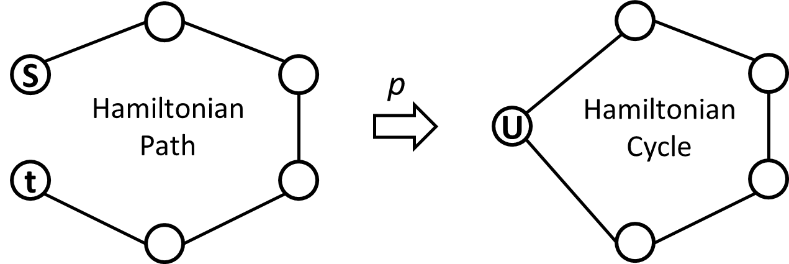
Note: The Path can be turned into a cycle by merging {s, t} into {u} or by adding an edge between s and t. Both options may be done in polynomial time.

Problem 5 (Primary Urabe / Alternate Scott)
Given a graph with distances, prove that finding a shortest s to t path is NP-Complete if some subset of vertices must be visited in the path.

Proof (Step 1) Instance: G=(V, E), s and t vertices in V. Let $d_{i, j}$ be the distance between vertices $i$ and $j$, and $k∈R$ be the path distance threshold. Let $V'$ $⊆$ V be the set of vertices that must be visited on the path.
Question: Does there exist a path from s to t such that $\sum_{ij}{d_{i,j}}≤k$, V’$⊆$V^{P}?
(Step 2) Given a candidate solution (path), check that it starts at s, ends at t, has every node in V’, is a path, and $\sum_{ij}{d_{i,j}}≤k$. This can be completed in polynomial time, thus it is in NP.
(Step 3) Convert a Hamiltonian Path into shortest path.
HP instance: G^{HP}=( V^{HP}, E^{HP})
Question: Does there exist a Hamiltonian Path from s to t in G? We know that HP is in NP.
A Hamiltonian Path starts at one vertex, ends at another, and visits each vertex of the graph exactly once. Let G^{HP} be a Hamiltonian Path that starts at s^{HP} and ends at t^{HP}. Create complete graph G^{HPC}=( V^{HPC}, E^{HPC}) from G^{HP} by adding all possible non-duplicated edges between the vertices such that E^{HPC}=$\left\{\left\{i,j\right\}:i, j∈V^{HP}\right\}$ and V^{HPC}=V^{HP}. To obtain a graph with distances, weight each edge such that $d_{i,j}=1$for $\left\{i,j\right\}ϵV^{HP}$ and $d_{i,j}=2$for $\left\{i,j\right\}∉V^{HP}$. Then set s^{HP}=s, t^{HP}=t, V’= V^{HP}, and k=n-1.
(Step 4) Prove that there exists a shortest path in G from s to t including a subset of vertices V’ if and only if there exists a Hamiltonian Path.
(To show is Hamiltonian Path: Show there exists a path that starts at s, ends at t, and visits each vertex of the graph exactly once.)
Proof: Assume there exists a path P in the complete graph generated from some V’$⊆$ V from s to t such that $\sum_{ij}{d_{i,j}}≤k=n-1$, $d_{i, j}$ the distance between vertices $i$ and $j$, V’$⊆$V^{P} and $k∈R$. P is a path from s to t that visits each vertex V’ by definition. It visits each vertex of the graph exactly once since P has at least n vertices and $\sum_{ij}{d_{i,j}}≤k=n-1$, therefore there are at most n-1 edges in P and P has exactly n vertices. Thus there exists a Hamiltonian Path.
Proof: Assume there exists a Hamiltonian Path HP from s to t in G=(V, E). By the reasoning of the complete graph with weightings in the reduction (Part 3), there exists a path from s to t such that $\sum_{ij}{d_{i,j}}≤k=n-1$, V’= V^{HP}. Thus there exists a shortest path that includes V’.

Problem 6 (Primary Cooke / Alternate Quint)
Find an algorithm that runs in O(n+m) which determines each of the components of a graph.

(Step 1) Let G = (V,E) be a graph. Start at any node x and label it in level 0. Find all of its neighbors, label them in level 1 and mark the edges connecting them to the level 0 node as used. For all nodes in level 1, find all their neighbors. For each of the previously unlabeled neighbors, label them in level 2 and mark the edges used. Continue for all nodes in level 2 and so on until you have used all edges incident to labeled nodes. At this point, since all edges incident to labeled nodes are found, there are no other nodes in this component. If there are any remaining unlabeled nodes, pick one at random and repeat the previous procedure until all nodes are found/labeled.
(Step 2) This finds all the nodes and edges in the graph grouped by components. The run time is O(n+m) because we use each edge to proceed through the algorithm. By labeling the edges as used, we only use each edge in the search once so that takes O(m). In the case where the graph is a set of n components (all nodes have degree 0), the algorithm would take n iterations (O(n)) to find each node. So the bounding function for run time in the worst case is O(n+m).
Problem 7 (Primary Krause / Alternate Anderson)
(Book Problem 3.25.) Knight's tour problem. Consider the chessboard shown in Figure 3.13. Note that some squares are shaded. We wish to determine a knight's tour, if one exists, that starts at the square designated by s and, after visiting the minimum number of squares~ ends at the square designated by t. The tour must not visit any shaded square. Formulate this problem as a reachability problem on an appropriately defined graph. (Graded)

Assumptions: (1) Minimal path requires each cell to be traversed only once along a path. (2) Each jump resets the direction of the arc; knight can move to any location not already used along its path.
1) Each open square represents a Vertex (V).
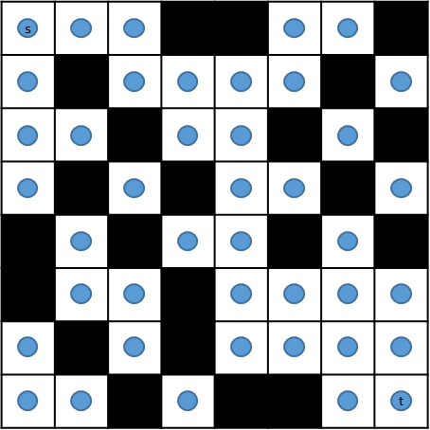

2) $V_{ij}$ is connected by one, eligible Knight move (E).

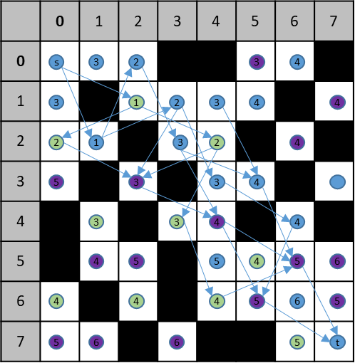

3) The shortest path (P) of eligible moves of the knight are represented in the directed network G=(V,E). The Graph, G (V,E) represents a set of Vertices (V)and Edges (E).
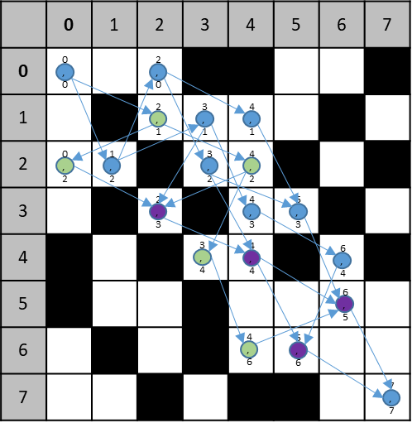

4) A path (P) exists along V(S,T) in the Graph. A sequence of V in P defines the shortest sequence of moves along the tour.
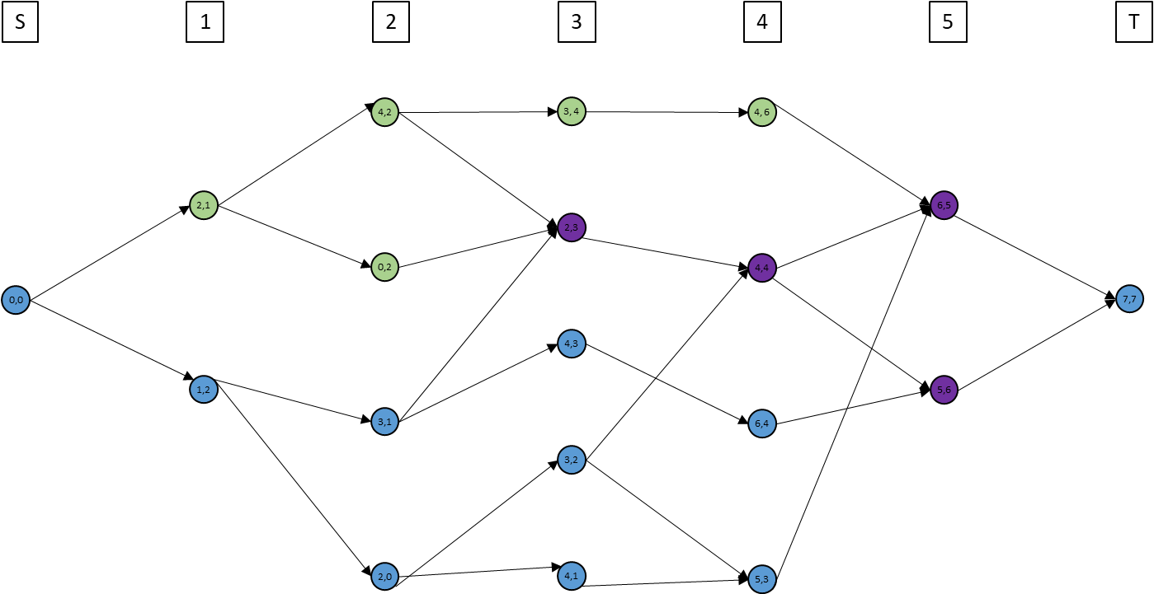

Problem 8 (Primary Cameron, Cooke, Anderson)
Find a O(n) algorithm to find the longest path in a tree. (Graded).
You must prove both the running time and the correctness of the algorithm.

Algorithm

  - Start at a random vertex x1.
  - Conduct BFS starting at x1.
    - UnvisitedNodes {X}
    - Add x1 to List, distance(x1) 0, predecessor(x1) x1
    - While the List is not empty:
      - nextNode List(0)
      - remove List(0) from List
      - For each neighbor i of nextNode:
        - If i is in UnivisitedNodes
          - set distance(i) to distance(nextNode) + 1
          - Set predecessor(i) equal to (nextNode)
          - and add (i) to the end of the List
          - remove nextNode from UnvisitedNodes
  - Find node x2 with largest distance from x1
  - Conduct BFS starting with x2 to find x5 (node with longest distance from x2)
  - Longest path is from x2 to x5

To prove of correctness we assert that:
- The first iteration of the BFS (steps b) finds one end node on a longest path in G (there may be multiple paths with same length).
- The second iteration of BFS (step d) finds the second endpoint on the longest path.

Proof that First iteration finds one end node of longest path.

Let G = (V,E) be a graph where {x1,x2,x3,x4,x5} is a subset of the nodes. Let x1 be the random node we used to start the search and x2 be the node that is farthest from x1. Assume towards a contradiction that x1 is not on the longest path in G, and instead x3 and x4 are the end nodes of the longest path. Since x2 is the farthest node from x1, x3 and x4 are no farther away from x1 than x2 is.

Assume WLOG that x3 is at least as close to x1 as x4 is. Since G is a tree, there is a unique path between any two nodes, so there is at least one node in common on the unique paths from x2 to x1 and from x3 to x1 (x1 may be the only common node on the paths). Since x2 is at least as far from x1 as x3 is and the fact there is only one unique path from the common point to x1, then x2 is no closer to the common point than is x3. Also since G is a tree, there is one unique path from the common point to x4. We have two cases for the path from the common point to x4:

1) The path from the common point to x4 goes through x3. This is a contradiction to our assumption that the path from x3 to x4 is the longest in G, because that would mean the path from the common point to x4 is longer.

2) The path from the common point to x4 does not go through x3 (that means the path from x3 to x4 goes through the common point otherwise we would have a cycle containing x3, x4, and the common point). We still have that x2 is at least as far from the common point as is x3 so the path from x2 to x4 is at least as long as the path from x3 to x4. Which means x2 is an endpoint on the longest path in the tree, which is a contradiction to our assumption.
Therefore, x2 must be an end node on the longest path in G.

(Proving that running the BFS with x2 finds the other endpoint on the longest path.) This is trivial because we know x2 is an endpoint on the longest path, the farthest point away it is the other endpoint on the longest path.

Proving run time is O(n)
Each of the two iterations of the search explores the m arcs and n nodes, giving a runtime of each of O(n+m). m is equivalent to n-1, so , as n goes to infinity, each iteration can be described as running at O(2n).

The iterations are not inside each other, they are sequential, so total runtime expressed in this manner is O(4n). As n approaches infinity, the runtime is O(n). Thus the runtime is O(n).

Runtime
O(n+m) + O(n+m)

m=n-1
As m ∞, m=n

O(2n) + O(2n) = O(4n)

As n ∞, 4n=n

Thus runtime is O(n).

